INSTITUTION LOGO | TITTLE SUGGESTED 1: [NAME OF THE ORGANIZATION] WILL CELEBRATE THE DAY OF SCIENTIFIC CULTURE
August 16th, 2021

The International Day of Scientific Culture -IDSC- will be celebrated this year to highlight the importance of scientific culture in today's society, focusing on activities and institutions that provide ways for people to appreciate science as an important part of their lives. The IDSC was held for the first time in 2020, in nine countries.
The day of September 28 was chosen to mark the anniversary of the launch of the series 'Cosmos', one of the most influential science outreach programs in history, began.
More than 100 institutions from 30 countries in four continents will participate in the 2021 edition of the IDSC expressing their mission to contribute to strengthening of scientific culture: scientific associations, networks of science communicators, research centres, ministries and councils of science, technology and innovation, museums and science centers, secretariats of education, teachers' associations, educational centers, universities, ministries of communication, NGOs dedicated to the public communication of science and associations of professionals from various scientific disciplines.
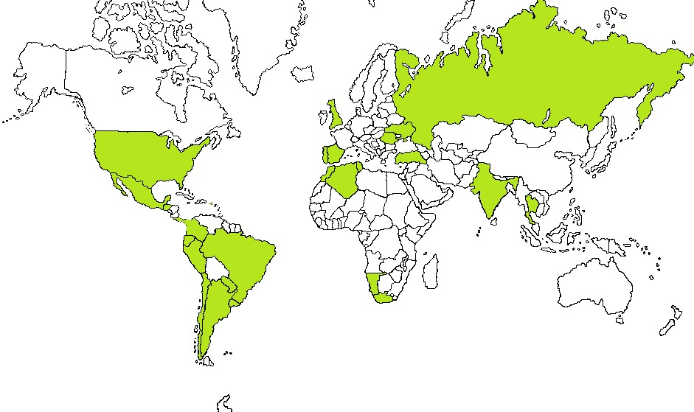

For more information on the IDSC and those who participate, visit the websites:
Spanish: https://somedicyt.org.mx/divulgacion/dicc
English: https://somedicyt.org.mx/divulgacion/dicc/idsc
You can check the activities that [NAME OF THE ORGANIZATION] will carry out, in:
PASTE THE LINK OF THE WEBSITE OR SOCIAL NETWORK OF YOUR INSTITUTION WHERE THE INFORMATION OF THE CELEBRATION OF THE IDSC WILL BE AVAILABLE.
For more information:
NAME OF THE INSTITUTION
Name of contact person
e-mail or phone number of contact person

